## **Artificial Intelligence Industry of Eastern Europe Uncovered**

### **Evolution of AI Sector in Eastern Europe Has Led to State of Notable Position in the Global AI Economy Alongside**

### **Europe, Asia and North America.**

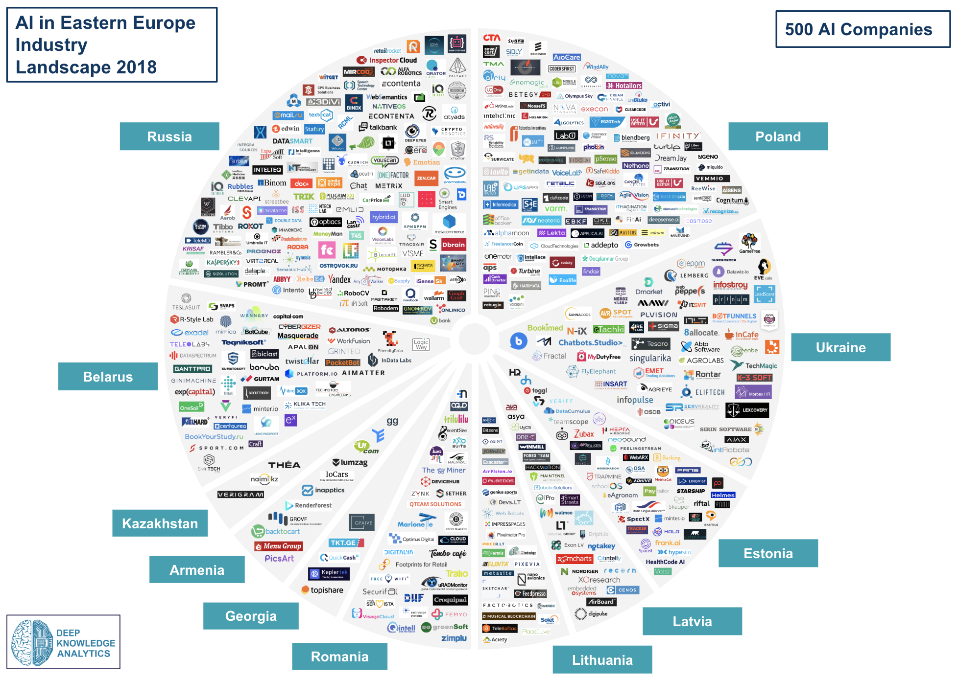

London, 6 February - Deep Knowledge Analytics announces publication of a first-of-its-kind 200-page analytical report on the state of the AI Industry in Eastern Europe.

[***AI in Eastern Europe Landscape Overview 2018***](https://www.dka.global/ai-in-eastern-europe)features an overview of the size and market segmentation of the AI industries of Belarus, Geоrgia, Armenia, Kazakhstan, The Bаltic States, Poland, Russia, Romania and Ukraine. The report also features in-depth comparative analyses showing which countries lead the region in terms of specific AI sectors and market niches, and compares the pace of industry progress in various countries when resources like government support and GDP are taken into account (finding, for example, that Poland has almost the same size of the AI ecosystem as Russia, despite being 3 times smaller than Russia in terms of GDP).

This new report aims to outline the history, present state and future of the Artificial Intelligence industry in 11 Eastern European countries, profiling 500 companies, 230 investors, 60 influencers, 30 Hubs & Accelerators and 15 conferences.

The document is divided into 2 volumes:

* Volume I presents a broad overview of the Artificial Intelligence industry in Eastern Europe, with key emphasis on the launch of national development agendas by Eastern European governments, and highlights key technological trends, industry subsectors, and comparison of the core strengths of different countries within the region.
* Volume II offers in-depth profiles of the large majority of the artificial intelligence industry players and stakeholders, both on an individual and an organizational level, in an effort to provide readers with an overarching overview of trends and sectors within the Eastern Europe artificial intelligence industry.

In line with Deep Knowledge Analytics other industry analytical reports, *AI in Eastern Europe Landscape Overview 2018* employs comprehensive infographics to distill the report's data and conclusions into easily understandable overviews, and summarizes the report's main findings and conclusions in its 11-page executive summary.

Some key findings of the report include:

* Countries like Poland, Romania, Estonia are progressing at a rapid pace due to their support of disruption-focused startups and development strategies, as well as aggressive entry into untapped market sectors. While Russia still leads the region, the rate of progress and industry development displayed by other countries indicates that they have the potential to rival Russia through the deployment of sufficiently-advanced national development strategies and the establishment of core partnerships and allegiances with EU nations.
* In addition to several national development strategies coming out of Eastern European countries, the past few years has seen a substantial influx of support towards Eastern European AI industry development from EU officials in Brussels. Those countries that proactively leverage this support stand the strongest chance of leading industry developments in the region within the next 5 years.
* In both parts of Eastern Europe (EU and CIS), AI companies are largely oriented towards EU or US-based clients. Similarly, Western countries are the largest source of investment into Eastern European AI companies. However, this situation is poised to shift dramatically. Asia led by China, but with Singapore and Hong Kong making substantial contributions, has become a proactive and aggressive leader of AI industry development and investment. As the socio-economic situation in Eastern Europe continues to shift, the likelihood that Asia will begin targeting Eastern European AI companies for partnerships and investments continues to increase.

The full report can be accessed via the following link:

<https://www.dka.global/ai-in-eastern-europe>

**About Deep Knowledge Analytics**

[Deep Knowledge Analytics](https://dka.global/) is the analytical department of [*Deep Knowledge Ventures*](https://www.dkv.global/)*,* an investment fund focused on DeepTech. Investment sectors include AI, Precision Medicine, Longevity, and Neurotech. Deep Knowledge Analytics regularly produces advanced industry analytical reports on the subjects of Artificial Intelligence, Longevity, and Blockchain, and specialises in forecasting on the Convergence of Technological MegaTrends.

For further information, please contact:

**Email:** info@dka.global

**Web:** [www.dka.global](http://www.dka.global)