PRESS RELEASE

Major Inconsistencies in Recent IPO Scandal Revealed

Deep Knowledge Analytics Independent Investigation Into Recent Claims of Misconduct Against NASDAQ-Listed Company Uncovers False Claims & Research Flaws for Accusers

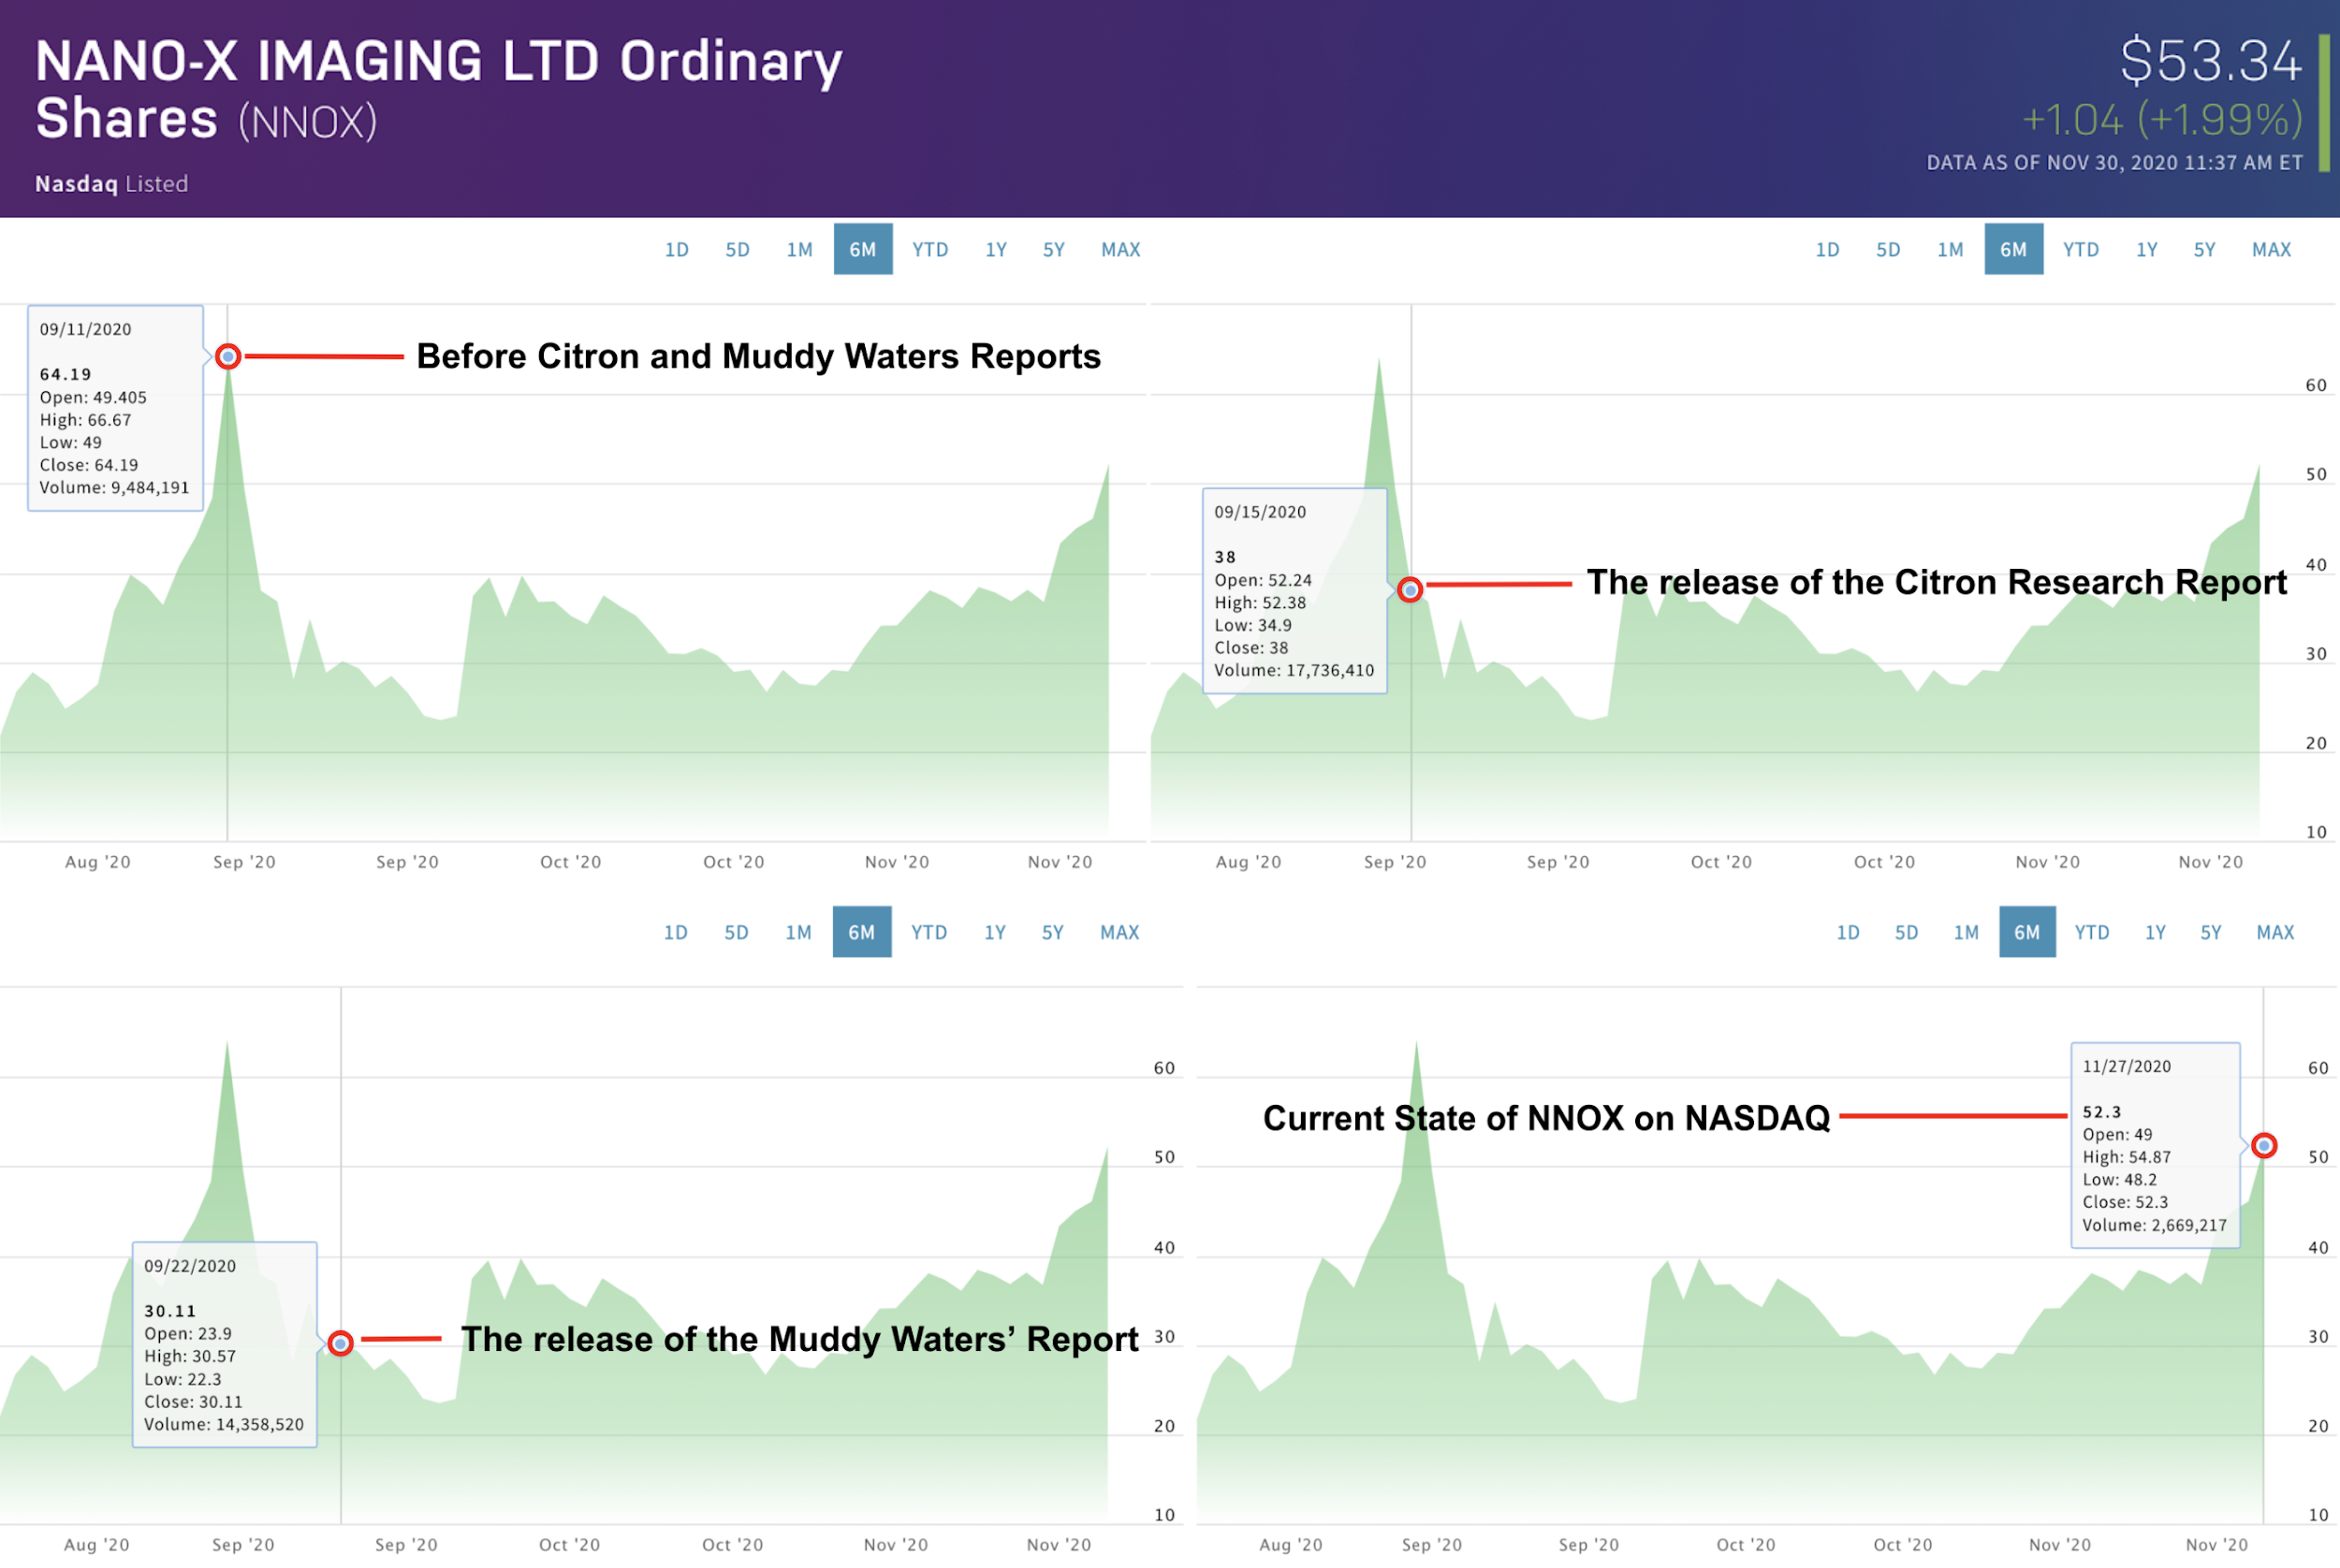

2nd of December 2020, Wednesday, London, UK: Deep Knowledge Analytics conducted and released today an independent analysis regarding Citron Research and Muddy Waters short-sell campaign against Israeli Nasdaq traded company “Nanox”.

The analysis include 4 different pieces, named “Nanox Company Composite Analysis”, “Informational Note (Summary): Analysis of 'Unusual Trading Activity' Surrounding Nanox in 2020”, “Informational Summary about Short Sellers: Citron Research and Muddy Waters”, and full report “Unusual Trading Activity’ at Nasdaq related to the shares of Nanox”.

The report looked into the allegations made against Nanox in September 2020, shortly after Nanox’s IPO and concluded that the investment research companies were part of an orchestrated media attack aiming to promote short-sale-related capital gains by artificially lowering the share price of Nanox.

The independent analysis has led to the conclusion that the Short Sellers Reports’ research and core arguments are based on unsubstantiated assumptions lacking concrete evidence, a disregard of minimum standard practices for objective and unbiased market research and analysis, and the use of provocative and dramatically-worded language, with the primary aim of damaging the reputation of Nanox in an aggressive manner with unprofessional, jargon language and comparison with fraud companies.

All claims made by the Short Sellers Reports can be seen either to be based on false and demonstrably falsifiable claims and assumptions, or to be clear instances of unsubstantiated libel and personal attacks lacking proper contextualization and omitting supplementary information that would otherwise counterbalance the claims being made.

“If we were to follow the logic of these Short Sellers Reports to their fullest extent, it could be concluded that all innovative, DeepTech-driven companies working on something fundamentally new and disruptive may be easily accused in fraud”, adds Co-founder at Deep Knowledge Analytics Mr. Dmitry Kaminskiy, “DeepTech-driven companies deserve additional support and protection against false accusations for the benefit of technological progress.”

The full report can be accessed here: https://www.dka.global/nanox-imaging

About Deep Knowledge Analytics
Deep Knowledge Analytics is a DeepTech focused agency producing analytics, market intelligence, pragmatic data-driven forecasting and tangible industry benchmarking on DeepTech and innovative technologies using sophisticated Big Data analysis, Data Science techniques and modern IT-solutions. It is an analytical subsidiary of Deep Knowledge Group, an international consortium of commercial and non-profit organizations focused on the synergetic convergence of DeepTech and Frontier Technologies.

