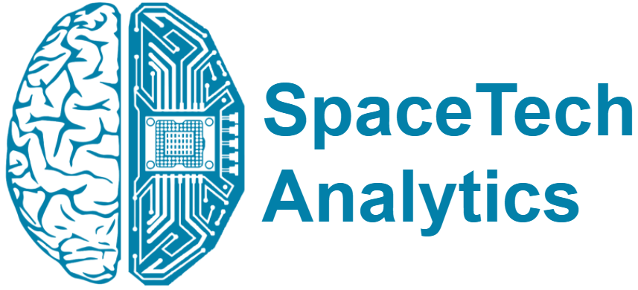
PRESS RELEASE
Extensive Analysis of National Space Programmes in Landmark Analysis
New Specialized Think Tank SpaceTech Analytics Has Profiled National Space Programs, 150 R&D Hubs and Associations, and 130 Government Organizations
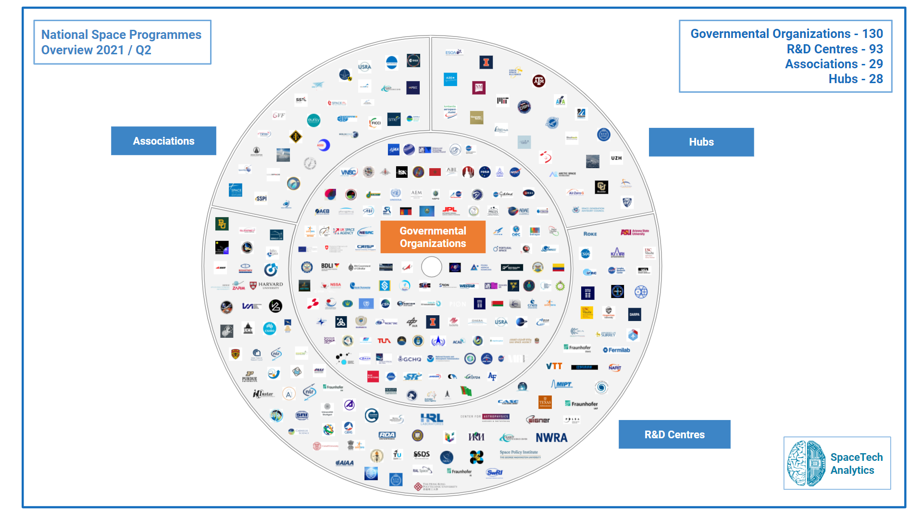
1:00 PM BST, 27th May 2021, London, UK: SpaceTech Analytics, a new spin-off of Deep Knowledge Group’s flagship subsidiary, Deep Knowledge Analytics, announces the release of an open-access 40-page special analytical case study, “National Space Programmes 2021 / Q2 Activity Overview,” designed to provide tangible industry insights and trends.
Link to the Special Analytical Case Study: www.spacetech.global/case-studies
Link to the Interactive Dashboard: www.spacetech.global/dashboard
The release delivers information about major industry trends and sector insights on 50+ countries with space exploration programs, 150 R&D hubs and associations, and 130 governmental organizations. While the special analytical case study, interactive mindmaps, and associated IT-Platform distill the major trends and key insights of the project for easy consumption by strategic decision makers, the associated SpaceTech Analytical Dashboard offers additional insights and interactive features that allow key market trends to be identified and analyzed with a higher degree of precision. The report and associated IT-Platform also forecast future developments in SpaceTech and consolidate the investors, companies, hubs, and governmental agencies positioned to make the most progress in terms of growth and market impact in the coming years.

The report touches upon several countries that are currently at the forefront of the industry. The USA is leading the industry with NASA. China is catching up with its space program and is on the way to cooperate with the Russian Federation. The Indian Space Research Organization has a strong SpaceTech agenda and is expected to have an even faster development rate. The United Arab Emirates’ space program could almost be called miraculous, since no other country has managed to achieve what they have done in such a short time. Agencies such as the Japan Aerospace Exploration Agency and the European Space Agency are aiming for the “peaceful use of outer space.” In other words, they are striving not for superiority, but for progress in technology and science, thus making cooperation easy and advantageous.
Based on a comprehensive analysis of key market players and overall industry dynamics, the project has identified a number of major trends and insights into the most advanced space programs and plans for the future in terms of space exploration, and many other essential aspects in the first iteration. Some of the analysis’s takeaways include the following:

- The analysis revealed a trend of cooperation between various agencies, including private companies (NASA and SpaceX; Artemis and Boeing).
- The development of governmental agencies has accelerated during the last 10 years.
- The number of government space agencies is increasing. There are 11 new agencies that are expected to emerge in the coming years.
The data presented by SpaceTech Analytics’s “National Space Programmes 2021 / Q2 Activity Overview” are presented and visualized so as to enable strategic decision-makers to extract insights and other valuable, tangible information more easily, with the ultimate aim of optimizing their investment management strategies, assisting and promoting the accelerated growth of the SpaceTech industry as a whole.
The release is a part of an inaugural 165-page case study Space Industry Landscape Overview, dedicated to providing deep technical insights, business intelligence, and strategic guidance in the high-growth and significant-opportunity companies of the space exploration industry, including satellite technologies, emerging propulsion systems, reusable launch vehicles, space medicine, promising startups, and more.
The company will also be releasing an analytically sophisticated second edition of the report and Dashboard later in 2021 that will incorporate big data analytics, machine learning, AI engine, and investment analytics technologies already developed and validated by SpaceTech Analytics's parent company, Deep Knowledge Group, and its various analytical subsidiaries (including Aging Analytics Agency and Deep Pharma Intelligence).

About SpaceTech Analytics
SpaceTech Analytics is a strategic analytics agency focused on markets in the Space Exploration, Spaceflight, Space Medicine, and Satellite Tech industries. Its range of activities includes research and analysis on major areas of high potential in the SpaceTech industry; maintaining profiling of companies and government agencies based on their innovation potential and business activity; and providing consulting and analytical services to advance the SpaceTech sector.

About Deep Knowledge Analytics
Deep Knowledge Analytics is a DeepTech-focused agency producing advanced analytics on DeepTech and frontier-technology industries using sophisticated multi-dimensional frameworks and algorithmic methods that combine hundreds of specially-designed and specifically weighted metrics and parameters to deliver insightful market intelligence, pragmatic forecasting, and tangible industry benchmarking.

For press and media inquiries, cooperation, collaboration, and strategic partnership proposals, please contact: info@spacetech.global

