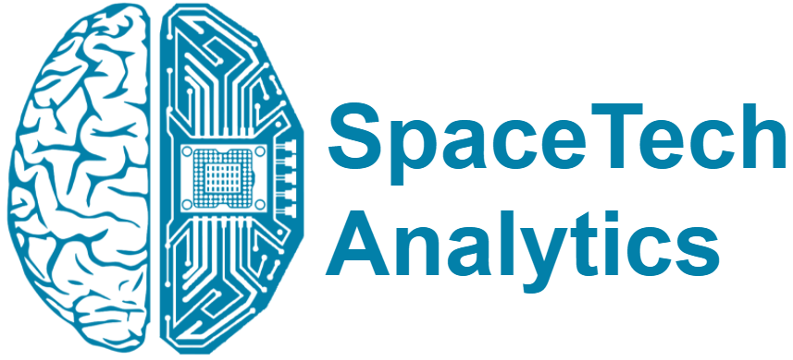
PRESS RELEASE
Publicly Traded SpaceTech Companies Completely Profiled for the First Time in Landmark Analysis
New Specialized Think Tank SpaceTech Analytics Has Analysed the 2021 Publicly Traded Companies in the Global SpaceTech Sector, Covering 1,000+ Entities
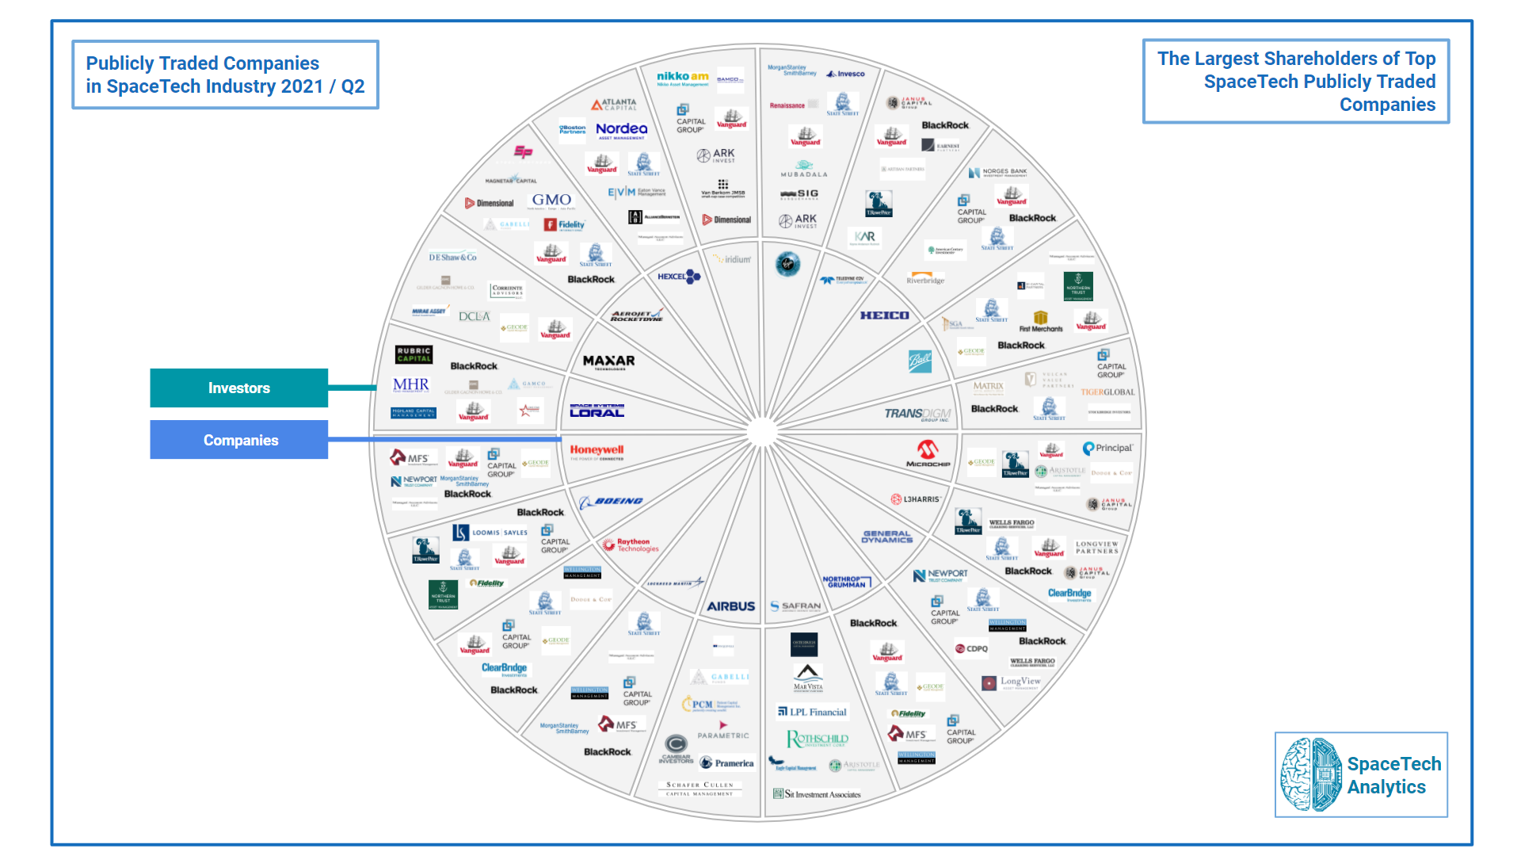
1st June 2021, London, UK: SpaceTech Analytics, a new spin-off of Deep Knowledge Group’s flagship subsidiary, Deep Knowledge Analytics, announces the release of an open-access 40-page special analytical case study, “Publicly Traded Companies in SpaceTech Industry 2021 / Q2,” designed to provide tangible insights and trends on companies and investors.

Link to the Special Analytical Case Study: www.spacetech.global/case-studies
Link to the Interactive Dashboard: www.spacetech.global/dashboard

The release delivers information about major industry trends and sector insights on 350+ SpaceTech publicly traded companies and 700 investors in the area of space exploration. While the special analytical case study, interactive mindmaps, and associated IT-Platform distil the major trends and key insights of the project for easy consumption by strategic decision makers, the associated SpaceTech Analytical Dashboard offers additional insights and interactive features that allow key market trends to be identified and analyzed with a higher degree of precision. The report and associated IT-Platform also forecast future developments in SpaceTech and consolidate the investors, companies, hubs, and government agencies positioned to make the most progress in growth and market impact in the coming years.

The report characterizes the publicly traded companies from the space industry by a variety of financial factors. There are points of information about capitalization, investment volumes, stock returns, and so on. You can also find information about the SpaceTech companies that are about to go public and about one of the biggest Exchange Traded Funds (ETFs) in the industry. There is a list of companies that it invests in. These public companies became the most discussed: Virgin Galactic (SPCE), Boeing (BA), Northrop Grumman (NOC), Lockheed Martin (LMT), Aerojet Rocketdyne (AJRD), Iridium (IRDM).
Some of the analysis’s takeaways include the following:

- The growing number of IPOs in the SpaceTech industry shows a high level of interest among investors in this sector. The number of IPOs in the SpaceTech industry rose from 2 in 2019 to 5 in 2020.
- The space industry will grow by $10 trillion in the next decade.
- With a total of $28B invested in 3,086 companies, the US is an undisputed leader in terms of SpaceTech investments. This is approximately 6 times the amount invested in SpaceTech companies in China – the second-largest country in terms of SpaceTech investment ($4.7B invested in 122 companies).
The data encompassed by SpaceTech Analytics in “Publicly Traded Companies in SpaceTech Industry 2021 / Q2” are presented and visualized so as to enable strategic decision-makers to extract insights and other valuable, tangible information more easily, with the ultimate aim of optimizing their investment management strategies, assisting and promoting the accelerated growth of the SpaceTech industry as a whole.
The release is a part of an inaugural 165-page case study, Space Industry Landscape Overview, dedicated to providing deep technical insights, business intelligence, and strategic guidance in the high-growth and significant opportunity companies of the space exploration industry, including satellite technologies, emerging propulsion systems, reusable launch vehicles, space medicine, promising startups, and more.
The company will also be releasing an analytically sophisticated second edition of the report and Dashboard later in 2021, which will incorporate big data analytics, machine learning, AI engine, and investment analytics technologies already developed and validated by SpaceTech Analytics's parent company, Deep Knowledge Group, and its various analytical subsidiaries (including Aging Analytics Agency and Deep Pharma Intelligence).

About SpaceTech Analytics
SpaceTech Analytics is a strategic analytics agency focused on markets in the Space Exploration, Spaceflight, Space Medicine, and Satellite Tech industries. Its range of activities includes research and analysis on major areas of high potential in the SpaceTech industry, maintaining profiling of companies and government agencies based on their innovation potential and business activity, and providing consulting and analytical services to advance the SpaceTech sector.

About Deep Knowledge Analytics
Deep Knowledge Analytics is a DeepTech focused agency producing advanced analytics on DeepTech and frontier-technology industries. We use sophisticated multi-dimensional frameworks and algorithmic methods to combine hundreds of specially designed and specifically weighted metrics and parameters to deliver insightful market intelligence, pragmatic forecasting, and tangible industry benchmarking.

For press and media inquiries, cooperation, collaboration, and strategic partnership proposals, please contact: info@spacetech.global

