PRESS RELEASE
SpaceTech Analytics Developed First-of-its-kind “Spaceness Index” to Profile the Global Industry in Landmark Analysis
Specialized Think Tank SpaceTech Analytics Has Classificated and Analyzed the 2021 Global SpaceTech Industry with its own Methodology, Covering 16 000+ Entities 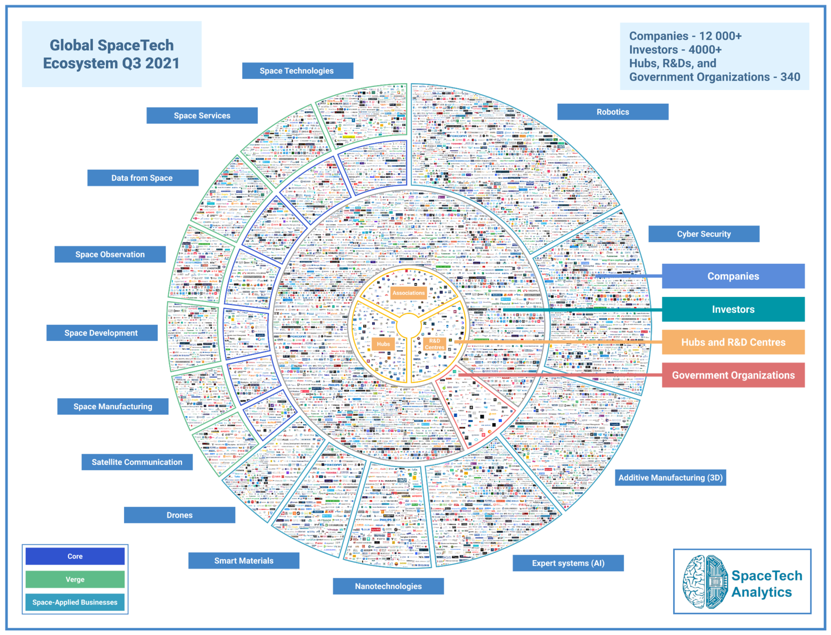
30th September 2021, London, UK: SpaceTech Analytics, a Deep Knowledge Group’s flagship subsidiary, announces the release of an open-access, 245-page special analytical case study, interactive IT-Platform, and Dashboard designed to provide tangible industry insights, market trends, companies, investors, technologies benchmarking, and forecasting on the Global SpaceTech Industry: “SpaceTech Industry 2021 Landscape Overview.”

Link to the Special Analytical Case Study: www.spacetech.global/spacetech-industry-q3-2021
Link to the Interactive Dashboard: www.spacetech.global/dashboard

The release delivers information about major industry trends and sector insights on 12 000+ SpaceTech companies, 4 000+ investors, 200 R&D hubs and associations, and 140 government organizations in the area of space exploration with applied first version of “spaceness index” delivered in a form of methodology to sort companies in “core”, “verge” and “space-applied” groups.
Based on a comprehensive analysis of key market players and overall industry dynamics, the project has identified a number of major trends and insights about the investment landscape, R&D collaborations, and many other essential aspects in the second iteration. Some of the analysis’ takeaways include the following:

- Small satellites are actively expanding in the SpaceTech market. Small satellites are very light and may mass as little as 30 kg. Unfortunately, it is not generally affordable and reasonable to launch one small satellite. However, launching dozens or hundreds of satellites reduces costs significantly, which makes launches more accessible. On January 24th 2021, SpaceX set a record and launched 143 satellites on a single rocket for $57M on a Falcon 9.
- Today, commercial space transportation is the primary means of delivery to Earth orbit. Soon, this will include commercial in-space transportation systems and their support infrastructure. There are commercial in-space transportation companies now. Today, one can book payload delivery to the Moon on expendable commercial lunar landers with Astrobotic for $1.2M per kilogram.
- Potential lunar resources may encompass processable materials such as volatiles and minerals and geologic structures such as lava tubes that together might enable lunar habitation. The industrial development of asteroids involves extracting raw materials on asteroids and space bodies in the asteroid belt and especially in near-Earth space (in terms of velocity to get to them).
- Space is becoming relatively more accessible and affordable, allowing smaller countries to launch satellites with less effort and fewer resources. As a result, many countries in Africa, Latin America, and Asia have begun developing space technologies. For example, Kenya and Bahrain have joined the list of countries operating satellites.
- Space Medicine is a new frontier sector along with longevity. Long-duration spaceflight needs to be investigated more thoroughly. It is known that weightlessness influences muscle loss, bone loss, renal dysfunction, cardiovascular system, immune system, as well different neurological disorders and behavioral health. This will likely change in the coming era of space tourism.

Some of the financial takeaways in the SpaceTech industry:
- North America is the leading region by SpaceTech companies, with more than 6600 companies in the area. It is followed by Europe & Central Asia with 2681 companies and East Asia & Pacific with 1131 companies. The US is firmly in the lead regarding the number of Spacetech companies (52.1%). The UK ranks second (5.7%), while Canada, China, Germany, and India follow (4.9%, 4.5%, 3.8%, and 3.6%, respectively).
- Our top 20 “core” publicly traded companies by capitalization in 2021 include Korea Aerospace Industries, IHI Corporation, AT&T Inc., Honeywell International Inc., and The Boeing Company sharing the first five places. While the cumulative capitalization of all publicly traded companies analyzed is estimated to be more than $4T.
- Space is not only about space companies. The SpaceTech industry is experiencing rapid growth with entities that were not space-related initially, but have expanded into the sector. We include the top 20 “verge” SpaceTech companies that have recently started to contribute to the industry or are positioning to establish themselves in this sector. These include Amazon with the project "Kuiper", Jacobs and its Space Exploration Challenges, Intel with the first AI technology enablers to supply its VPU in a "satellite-as-a-service" space mission, and Garmin's GPS systems.

SpaceTech Analytics has analyzed 16 000+ entities and concluded that the capitalization of the whole industry is underestimated. Thus, we have developed a unique methodology that includes three major groups: “Core” companies, “Verge” companies, and “Space-Applied Businesses”. This approach allowed us to create the most extended and advanced database in order to estimate the size of the industry.

This Industrial report involved leading organisations all over the world, developing SpaceTech Industry, those include: Kleos, Integral Media LLC, For All Moonkind, SpaceBorn United, Trans Astra Corporation, Interplanetary Enterprises LLC, Cislunar Space Development Company, Secure World Foundation, Space Economy Rising, CONFERS, Space Tourism Society, Moon Village Association, Orbit Fab, The Armor Group, Inc., Colorado School of Mines, Canadian Space Mining Corporation, and CisLunar Industries.

In addition to providing company descriptions, this project is designed to issue strategic recommendations and guidance regarding space-related technologies and techniques within the reach of companies, other entities, and nations, in order to help them optimize their plans and strategies, providing specialized guidelines for business, and investment core decisions.

About SpaceTech Analytics
SpaceTech Analytics is a strategic analytics and investment agency focused on markets in the Space Exploration, Spaceflight, Space Medicine, and Satellite Tech industries. The range of activities includes research and analysis on major areas of high potential in the SpaceTech industry, maintaining profiling of companies and governmentа agencies based on their innovation potential and business activity, and providing consulting and analytical services to advance the SpaceTech sector.

About Deep Knowledge Analytics
Deep Knowledge Analytics is a DeepTech focused agency producing advanced analytics on DeepTech and frontier-technology industries using sophisticated multi-dimensional frameworks and algorithmic methods that combine hundreds of specially-designed and specifically-weighted metrics and parameters to deliver insightful market intelligence, pragmatic forecasting, and tangible industry benchmarking.

For press and media inquiries, cooperation, collaboration, and strategic partnership proposals, please contact: info@spacetech.global

