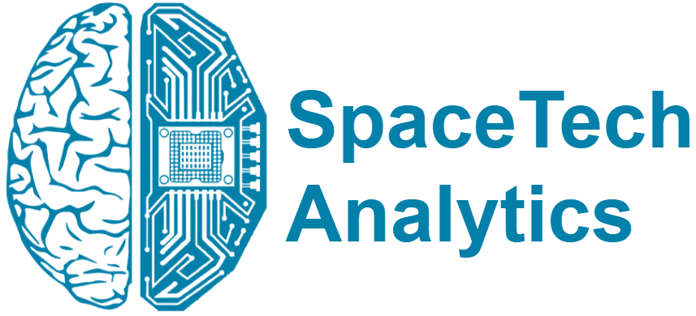
PRESS RELEASE
SpaceTech Analytics Prepared a Year Recap
SpaceTech Analytics Has Summarised Some of The Most Important And Promising Milestones of The Year 2021

6th January 2022, London, UK: SpaceTech Analytics, a Deep Knowledge Group’s flagship subsidiary, announces the release of an open-access, 75-page analytical report, “SpaceTech Industry Year Overview” designed to provide a year overview on companies and investors of the whole SpaceTech industry.
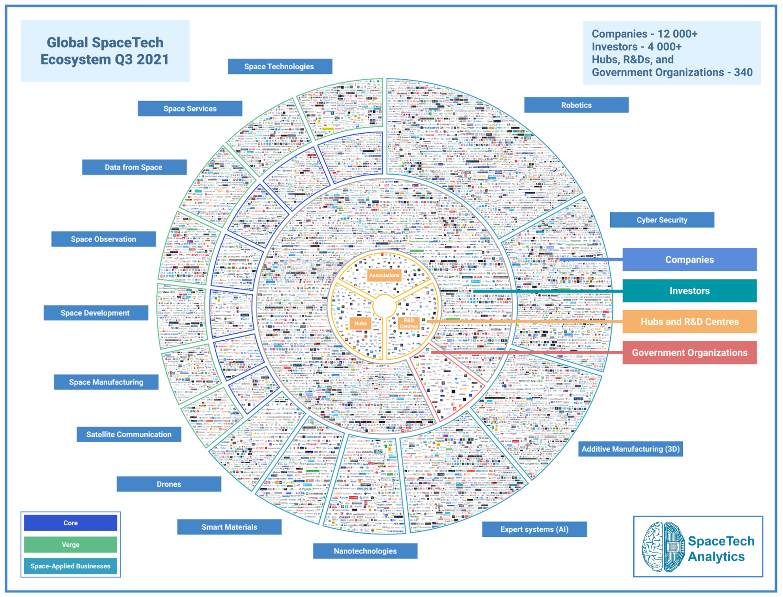
Link to the Report: https://analytics.dkv.global/spacetech/sрасеtech_industry_year_2021_overview.pdf
Link to the Interactive Dashboard: www.spacetech.global/dashboard

In this report, SpaceTech Analytics focuses on the state and development of SpaceTech during 2021. The release delivers information about industry trends and insights based on the database consisting of 12 000 SpaceTech companies, 4 000 investors, and 170+ publicly traded corporations from the SpaceTech Industry.

Based on a comprehensive analysis of key market players and overall industry dynamics, the project has identified a number of major trends and insights about the SpaceTech sector that emerged during 2021. Some of the analysis’ takeaways include the following:

- The space industry market continues to grow rapidly as the overall capitalization of the market changed from $3.5T dollars to $4.5T dollars since the beginning of the year 2021.
- Private and public companies are growing in both strength and capabilities.
- The speed of research and development of space technologies is accelerating and appears to be unhindered by COVID-19.
- 2021 was a prominent year for innovation in the world of space technologies.
- More than a hundred companies have been involved in acquisitions and public offerings since the beginning of the year.

The data encompassed by SpaceTech Analytics in “SpaceTech Industry Year Overview” are presented and visualized so as to enable strategic decision-makers to extract insights and other valuable, tangible information more easily, with the ultimate aim of optimizing their investment management strategies, assisting and promoting the accelerated growth of the SpaceTech industry as a whole. SpaceTech Analytics is open to cooperation and sets up an active position in the industry for investment relations.

About SpaceTech Analytics
SpaceTech Analytics is a strategic analytics and investment agency focused on markets in the Space Exploration, Spaceflight, Space Medicine, and Satellite Tech industries. The range of activities includes research and analysis on major areas of high potential in the SpaceTech industry, maintaining profiling of companies and government agencies based on their innovation potential and business activity, and providing consulting and analytical services to advance the SpaceTech sector.

About Deep Knowledge Analytics
Deep Knowledge Analytics is a DeepTech focused agency producing advanced analytics on DeepTech and frontier-technology industries using sophisticated multi-dimensional frameworks and algorithmic methods that combine hundreds of specially-designed and specifically-weighted metrics and parameters to deliver insightful market intelligence, pragmatic forecasting, and tangible industry benchmarking.

For press and media inquiries, cooperation, collaboration, and strategic partnership proposals, please contact: info@spacetech.global

